Name ______________________________________

Final Exam Review

Work on the parts that you think will help you the most. Answers will be posted on Blackboard. We won’t have time to review all of the answers in class, so ask questions if you have them!

Part 1: Quasi-Experimental Designs

1. Identify the type of design. Draw the XO diagram for the design. Then identify the major limitations of that type of design.

a. A manufacturing company measured its workers’ productivity each week for eight weeks. In the middle of the study (after four weeks), the company reduced shift duration from 10 hours to 8 hours.
Interrupted time-series design
O O O O X O O O O
No control group

b. Students in one school are given a pretest on their attitudes toward drugs, then are exposed to an anti-drug program, and finally, are given a posttest. Students in a similar school are given the pretest, not exposed to an anti-drug program, and finally, are given a posttest.
Pretest-posttest nonequivalent groups design
O X O
- - - - -
O O
No random assignment
2. Identify the type of design. Then identify the major limitations of that type of design.

- X O₁ posttest-only nonequivalent groups design
- - - - - - - no pretest, no random assignment
O₁

- O₁ O₂ O₃ O₄ X O₅ O₆ O₇ O₈ interrupted time-series design
no control group

- O₁ X O₂ O₃ switching replication design
- - - - - - - - - - - - - - - - - - - no random assignment
O₁ O₂ X O₃

- O₁ X O₂ one-group pretest-posttest design
no control group

Part 2: Factorial Designs

1. For each question:
-Identify the specific type of factorial design.
-Check for main effects.
-Check for an interaction. If there is an interaction, identify what type of interaction it is.

a. In a college course, a class was given both an easy version of a test and a difficult version of the same test. The students in the class were categorized as having either high or low anxiety. The dependent variable is test scores.
2x2 mixed factorial design
Main effect of anxiety
Main effect of test difficulty
No interaction
 | Anxiety
Test Difficulty | Low | High
Easy | 90 | 75
Difficult | 80 | 65

b. This graph shows predicted mental health outcome based on a person’s genetics and their environment. Different people are in each condition.

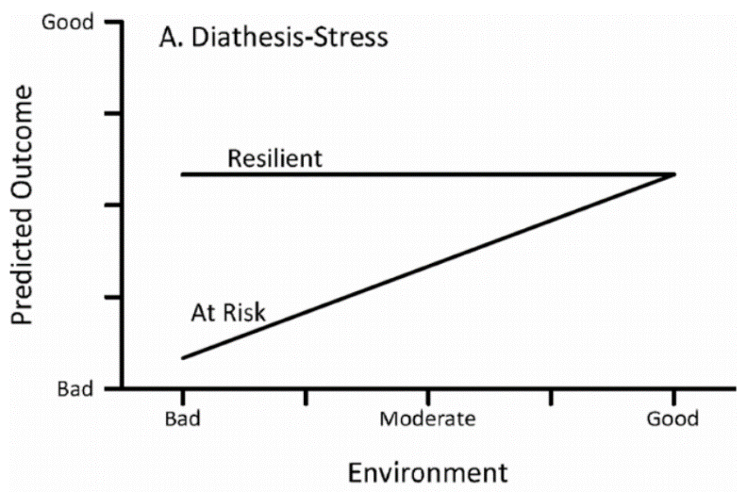
3x2 between-subjects factorial design
Main effect of environment
Main effect of genetics
Spreading interaction

c. This graph compares mean GPA across different types of colleges and different majors.
2x2 between-subjects factorial design
No main effect of college type
No main effect of major
Cross-over interaction
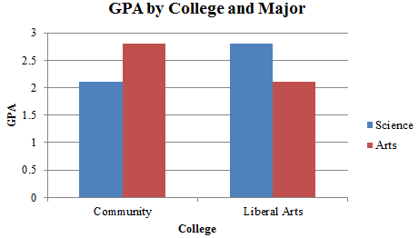

2. A researcher wants to study the effect of temperature and time of day on mood. Temperature is broken down into “hot” and “cold.” Time of day is broken down into “day” and “night.” Answer the following questions about this factorial design study:

a. What are the independent variables? How many levels does each independent variable have? List what those levels are for each independent variable.
Temperature – 2 levels (hot, cold)
Time of day – 2 levels (day, night)

b. What is the dependent variable?
Mood

c. How many conditions will there be in the study?
4

d. For each independent variable, if you found a main effect, what would that look like?
If we find a main effect of temperature, that will mean that overall, the average mood in a hot temperature is different from the average mood in a cold temperature.
If we find a main effect of time, that will mean that overall, the average mood during the day is different from the average mood at night.

e. If you found an interaction, what would that look like? Describe a specific example of an interaction we could find.
If we find an interaction, that will mean that the effect of temperature depends on the time or day, or vice versa. For example, we could find that mood is higher during the day when the temperature is hot, but that during the night, mood is higher when the temperature is cold. (This would be an example of a cross-over interaction.)

Part 3: Single-Subject Designs

- Applied behavior analysis is based on the principles of…
  - classical conditioning.
  - operant conditioning.
  - cognitive psychology.
  - group research.

- An ABAB design is a type of _____ design.
  - alternating treatments
  - multiple-baseline
  - reversal
  - changing criterion

- What term describes the time it takes for the dependent variable to start changing after the treatment is implemented?
  - Trend
  - Level
  - State
  - Latency

- What term describes whether the frequency of a behavior is increasing or decreasing?
  - Trend
  - Level
  - State
  - Latency

- What’s another name for single-subject designs?
  - Small-n designs
  - Time-limited designs
  - Between-subjects designs
  - Quasi-experimental designs

- A baseline phase is also called a(n) _____ phase.
  - A
  - B
  - intervention
  - treatment

- The steady-state strategy is primarily used to decide…
  - whether the intervention was effective.
  - when to transition to the next phase of the study.
  - how many participants to include in the study.
  - which type of single-subject design to use.

- Jon is a five-year-old boy who often becomes overwhelmed in emotional situations, has trouble communicating his needs, and engages in biting behavior when he gets frustrated. Jon’s divorced parents enlist an ABA psychologist to help them address Jon’s biting. The psychologist implements an intervention where Jon receives praise for engaging in healthy communication methods to show his frustration rather than biting. They implement the program at Jon’s dad’s house first, then at his mom’s house, and finally at school. What type of design is this?
  - Multiple-baseline design across settings
  - Multiple-baseline design across participants
  - Alternating treatments design
  - Reversal design

- A single-subject design might NOT be the best approach if…
  - you only have access to a small group of participants.
  - you care more about the effectiveness of a treatment for a specific individual than about generalizability.
  - you know your intervention has a strong effect.
  - participants are only available for a very brief period of time.

- Compared to other types of designs, single-subject designs place a particular emphasis on _____ validity.
  - external
  - statistical
  - social
  - construct
- Answer the questions about the graph.

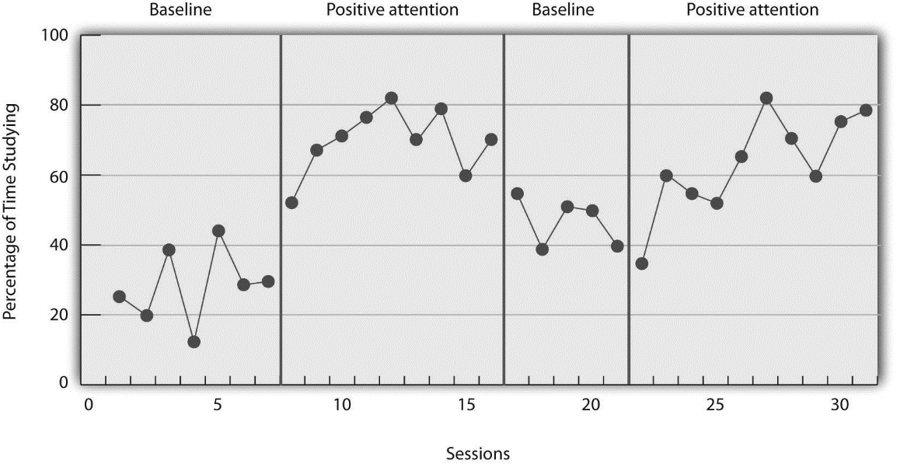
1. What kind of design is this?
ABAB reversal design

2. Would you say the treatment was effective or ineffective? Why?
Overall, it looks like the treatment was effective. We can examine the level, trend, and latency of the behavior in each phase. When the first treatment phase starts, there is an immediate increase in the behavior. When the reversal phase happens, the behavior decreases. When the second treatment phase begins, the behavior quickly increases again.

Part 4: Variables and Stats
1. Decide what NOIR level each variable is.
- Income level measured as <$30,000, $30,000-60,000, >$60,000 ordinal

- Body temperature measured in Fahrenheit interval

- Happiness rating on a 5-point scale interval

- Blood type nominal

- Number of schizophrenia symptoms ratio

2. Decide what inferential test would need to be used to test each hypothesis.
- People who eat broccoli are happier than people who don’t.
Independent-samples t-test

- Class scores on the final exam are higher than scores on the midterm exam.
Paired-samples t-test

- Biology students have more academic stress than students of any other major.
Between-subjects ANOVA

- People who are more optimistic are less likely to experience depression.
Pearson correlation
Part 5: Multiple Choice
Select the correct answer to each question.
1. Which is NOT true of single-subject designs?
a) They involve a sequence of baseline and intervention or treatment phases.
b) They only involve studying one individual.
c) They include built-in replications.
d). Each participant serves as their own control or comparison.

2. Which is true regarding the interpretation of factorial design results?
a) Marginal means are used to determine whether a main effect exists.
b) When there is an interaction, conclusions based only on main effects are accurate.
c) Parallel lines in a line graph suggest that there is an interaction.
d) Parallel lines in a bar graph suggest that there is an interaction.

3. Which of the following most closely describes a factorial design?
a) Researchers observe differences in attention among participants watching a movie presented at slow or fast speeds.
b) Researchers study the extent to which participants like drinks with different flavors (cherry, grape) and sugar content (5%, 20% sucrose).
c) Researchers compare cell phone use in a sample to actual cell phone use rates in the population.
d) Researchers investigate whether scores on an exam are related to the time students spent studying for the exam.

4. What is an operational definition?
a) A description of how exactly an experiment is going to be carried out.
b) A definition that is created during an experiment.
c) A definition of a variable in terms of precisely how it is to be measured or manipulated.
d) A general definition of a variable (as found in an encyclopedia).

5. Which of the following do true experiments and quasi-experiments have in common? (Select all correct answers.)
a) Manipulation of an independent variable
b) Measurement of a dependent variable
c) Control over extraneous variables
d) Equivalent groups

6. If a group of allergy sufferers are given an experimental medication and they are tested for allergies afterward, this would be an example of which design?
a) One-group pretest-posttest
b) One-group posttest-only
c) Interrupted time-series
d) Switching replication

7. Which factor describes the time it takes for the dependent variable to start changing after a change in conditions?
a) Trend
b) Level
c) Latency
d) State
8. Consider the following psychological experiment: Participants are put into either a happy or a sad mood by having them look at short videos of either an uplifting or depressing nature. They are then asked to rate pictures of people on their attractiveness. In this study, what is the independent variable?
a) Smalltalk
b) Personal compatibility
c) Depression
d) Mood

9. Participants’ height is measured in centimeters. This is an example of which level of measurement?
a) Nominal level
b) Ordinal level
c) Interval level
d) Ratio level

10. A study is investigating the risk of developing different psychological disorders based on a variety of environmental factors. During the study, the researchers switch from diagnosing participants based on the criterion in the DSM-IV to diagnosing based on the criteria in the DSM-V. This best represents an example of which threat to internal validity?
a) Selection
b) History
c) Testing
d) Instrumentation

11. Testing participants in different orders is referred to as ___ and is used in ___ experiments.
a) counterbalancing; between-subjects
b) random assignment; between-subjects
c) random assignment; within-subjects
d) counterbalancing; within-subjects

12. Compared to non-experimental designs, experimental designs have…
a) low construct validity
b) high construct validity
c) low internal validity
d) high internal validity

13. The steady state strategy is normally used in…
a) between-subjects groups research
b) single-subject research
c) non-experimental research
d) quasi-experimental research

14. A study that uses a non-representative sample is likely to have…
a) low internal validity
b) high internal validity
c) low external validity
d) high external validity

15. In a between-subjects design, …
a) all participants experience all conditions.
b) all participants experience just one condition.
c) all participants experience more than one condition, but not all conditions.
d) all participants experience all levels.

